### Project name: Pizza Delivery App

### (Developer)

**Team ID :** LTVIP2024TMID11241

**Team Leader :** POSAPATHI SAKETH VARMA

**Team member :** BARNATI PAVAN KUMAR

**Team member :** AKASAPU HEMANTH BHAVANI GANESH

**Team member :** G UMA MAHESH SAI

**Team member :** VASUPALLI NANI

**Team member :** PALLI DHANUNJAY

### Creation Of Developer Account

### Activity-1

A Developer org has all the features and licenses you need to get started with Salesforce.  
1. Search Developer.salesforce.com  
  
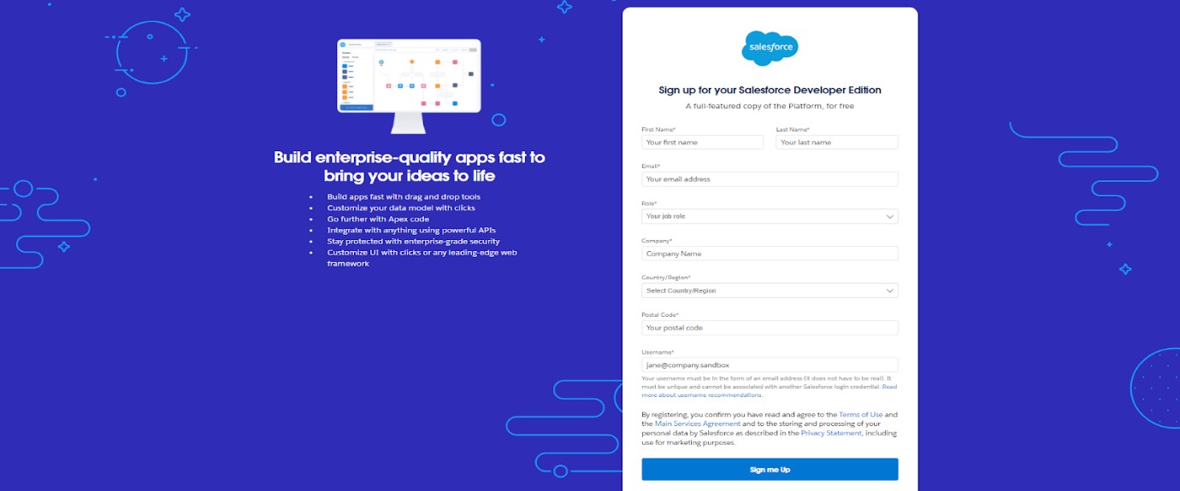  
  
2. Enter the following details like First name, last name, Email, Role, Company, Country/Region, Postal code, and Username must be unique.  
  
3. Click sign me up, After a few min you will reserve a mail salesforce org and by using the verify account link you can create your new password.  
  
  
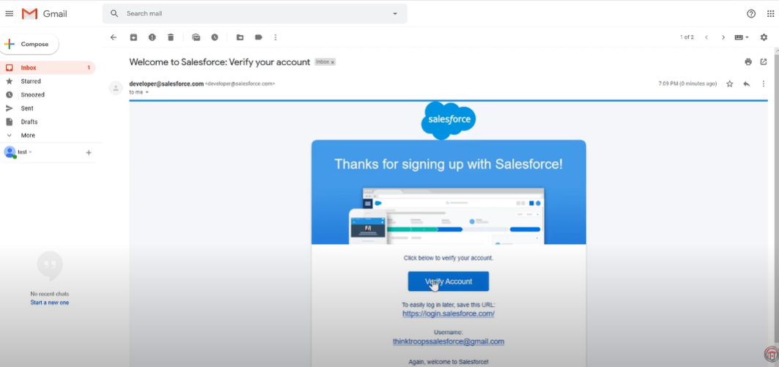  
  
4. Click save.  
5. Search login.salesforce.com  
6. By using username and password you can into the salesforce org.  
  
  
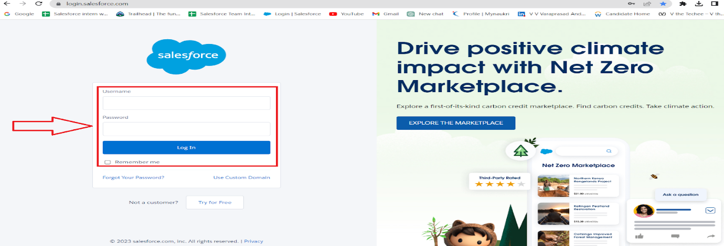  
  
The setup page will appear as below.  
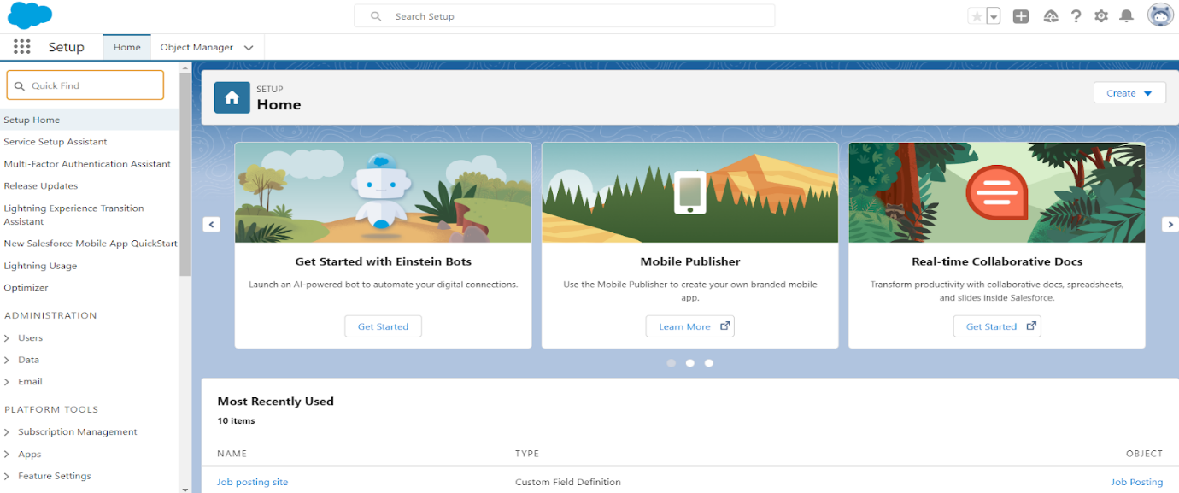  
Create a developer org and login with your login credentials.

### Object

**Create A Custom Object For Customer Detail**

To create a custom object, follow these steps :  
1. Click on the Gear Icon ? From setup click on object manager   
2. Click create, select custom object.  
  
  
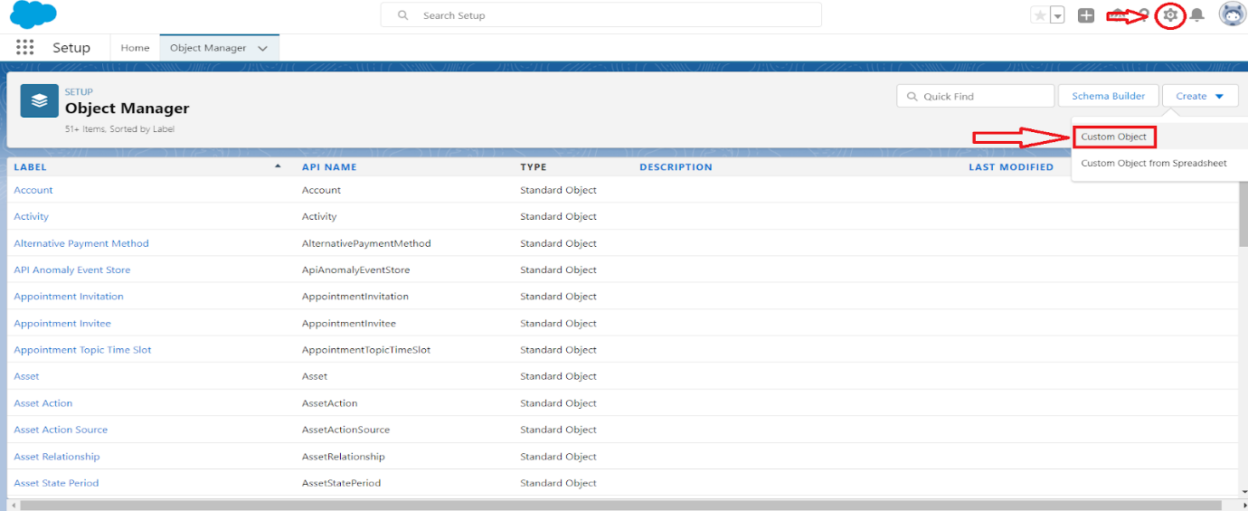  
3. Fill in the label as "Customer Detail".  
4. Fill in the plural label as "Customer Details".  
5. Record name : "Customer Name"  
6. Select the data type as "Text".  
7. In the Optional Features section, select Allow Reports and Track  
Field History.  
8. In the Deployment Status section, ensure Deployed is  
selected.  
9. In the Search Status section, select Allow Search.  
10. In the Object Creation Options section, select select these options:  
  
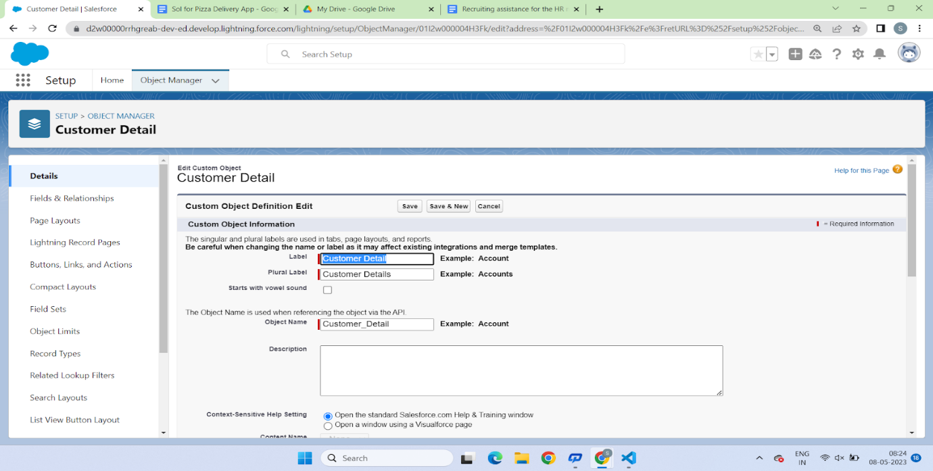  
  
Add Notes and Attachments related list to default page layout  
Launch New Custom Tab Wizard after saving this custom object  
11. Leave everything else as is, and click Save.  
  
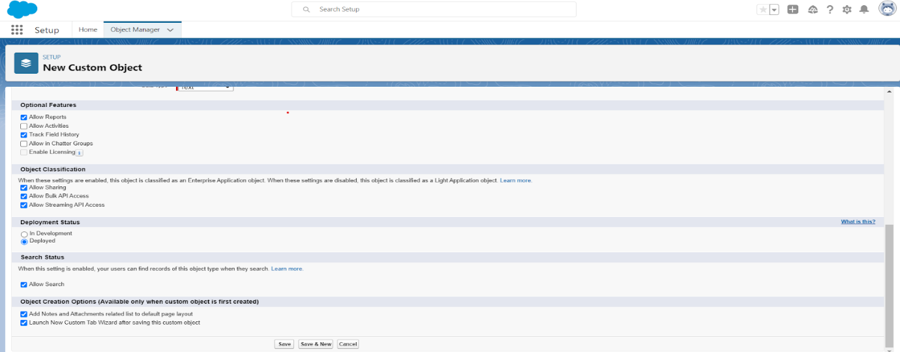

### Create A Custom Object For EveryDay Value

To create a custom object, follow these steps :  
1. Click on the Gear Icon ? From setup click on object manager

2. Click create, select custom object.  
3. Fill in the label as "EveryDay Value".

4. Fill in the plural label as "EveryDay Values".  
5. Record name : "EveryDay Value" 6. Select the data type as "Text".  
7. In the Optional Features section, select Allow Reports and Track Field History.  
8. In the Deployment Status section, ensure Deployed is selected.  
9. In the Search Status section, select Allow Search.

10. In the Object Creation Options section, select select these options:  
Add Notes and Attachments related list to default page layout Launch New Custom Tab Wizard after saving this custom object  
11. Leave everything else as is, and click Save.

### Create A Custom Object For Best Seller

1. Click on the Gear Icon ? From setup click on object manager   
2. Click create, select custom object.  
3.  Fill in the label as "Best Seller".  
4. Fill in the plural label as "Best Sellers".  
5. Record name : "Best Seller"  
6. Select the data type as "Text".  
7. In the Optional Features section, select Allow Reports and Track  
Field History.  
8. In the Deployment Status section, ensure Deployed is  
selected.  
9. In the Search Status section, select Allow Search.  
10. In the Object Creation Options section, select select these options:  
Add Notes and Attachments related list to default page layout  
Launch New Custom Tab Wizard after saving this custom object  
11. Leave everything else as is, and click Save

### Create A Custom Object For New Launches

1. Click on the Gear Icon ? From setup click on object manager   
2. Click create, select custom object.  
3. Fill in the label as "New Launch".  
4. Fill in the plural label as "New Launches".  
5. Record name : "New Launch"  
6. Select the data type as "Text".  
7. In the Optional Features section, select Allow Reports and Track  
Field History.  
8. In the Deployment Status section, ensure Deployed is  
selected.  
9. In the Search Status section, select Allow Search.  
10. In the Object Creation Options section, select select these options:  
Add Notes and Attachments related list to default page layout  
Launch New Custom Tab Wizard after saving this custom object  
11. Leave everything else as is, and click Save

### Create A Custom Object For Pizza(Record Type)

1. Click on the Gear Icon ? From setup click on object manager   
2. Click create, select custom object.  
3. Fill in the label as "New Launch".  
4. Fill in the plural label as "New Launches".  
5. Record name : "New Launch"  
6. Select the data type as "Text".  
7. In the Optional Features section, select Allow Reports and Track  
Field History.  
8. In the Deployment Status section, ensure Deployed is  
selected.  
9. In the Search Status section, select Allow Search.  
10. In the Object Creation Options section, select select these options:  
Add Notes and Attachments related list to default page layout  
Launch New Custom Tab Wizard after saving this custom object  
11. Leave everything else as is, and click Save

### Create A Custom Object For Beverages

1. Click on the Gear Icon ? From setup click on object manager   
2. Click create, select custom object.  
3. Fill in the label as "Beverage".  
4. Fill in the plural label as "Beverages".  
5. Record name : "Beverage"  
6. Select the data type as "Text".  
7. In the Optional Features section, select Allow Reports and Track  
Field History.  
8. In the Deployment Status section, ensure Deployed is  
selected.  
9. In the Search Status section, select Allow Search.  
10. In the Object Creation Options section, select select these options:  
Add Notes and Attachments related list to default page layout  
Launch New Custom Tab Wizard after saving this custom object  
11. Leave everything else as is, and click Save

### Create A Custom Object For Mode Of Payment

1. Click on the Gear Icon ? From setup click on object manager   
2. Click create, select custom object.  
3. Fill in the label as "Mode Of Payment".  
4. Fill in the plural label as "Mode Of Payments".  
5. Record name : "Mode Of Payment"  
6. Select the data type as "Text".  
7. In the Optional Features section, select Allow Reports and Track  
Field History.  
8. In the Deployment Status section, ensure Deployed is  
selected.  
9. In the Search Status section, select Allow Search.  
10. In the Object Creation Options section, select select these options:  
Add Notes and Attachments related list to default page layout  
Launch New Custom Tab Wizard after saving this custom object  
11. Leave everything else as is, and click Save

### Tabs

### How To Create A Tab

As we selected to launch a custom tab wizard in step 10, a custom tab wizard appears wherein We customize the look of the "Customer Detail". object's tab. To do that :  
  
1. To Create the tab ? click on the gear Icon ? then click Home button ?In the quick find box search for the Tabs.  
  
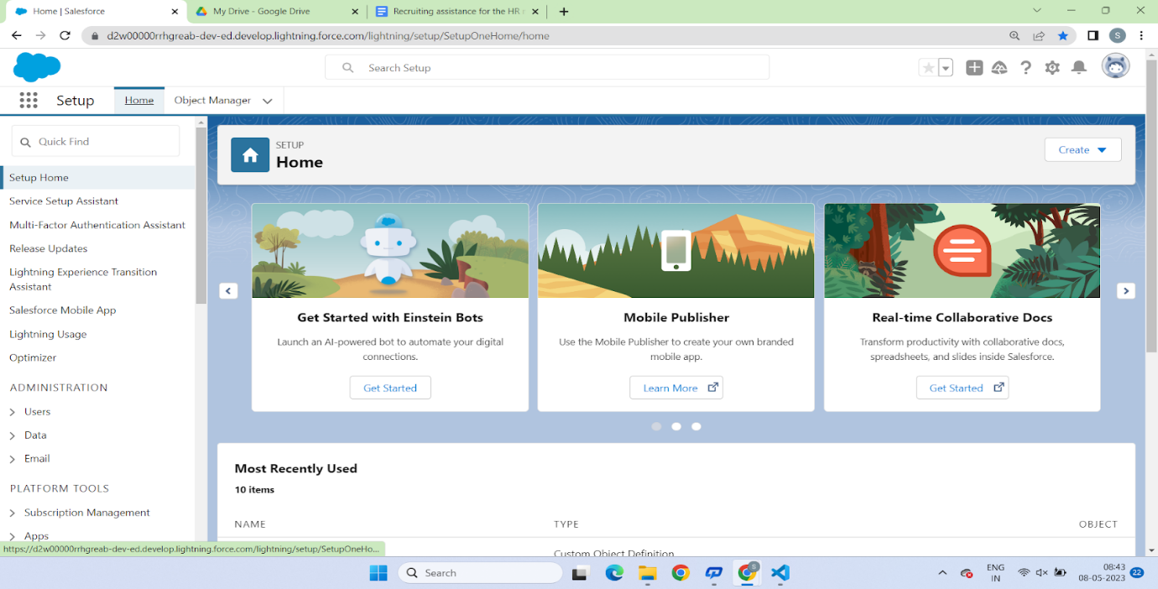  
  
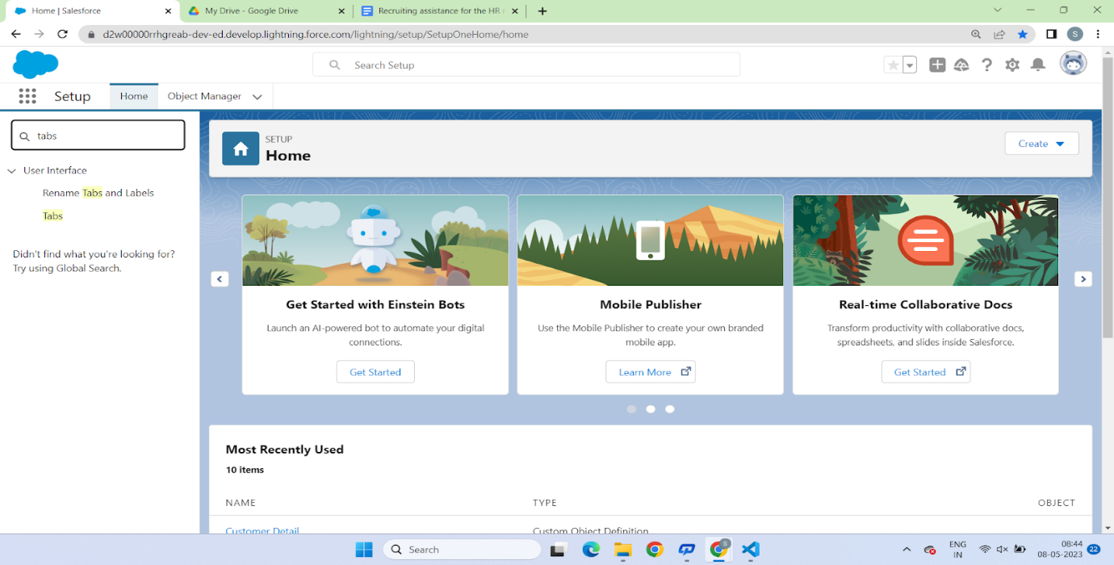  
  
  
3. Then Click on the new button to create tab, in the Tab style you can select whatever you want to select  
  
  
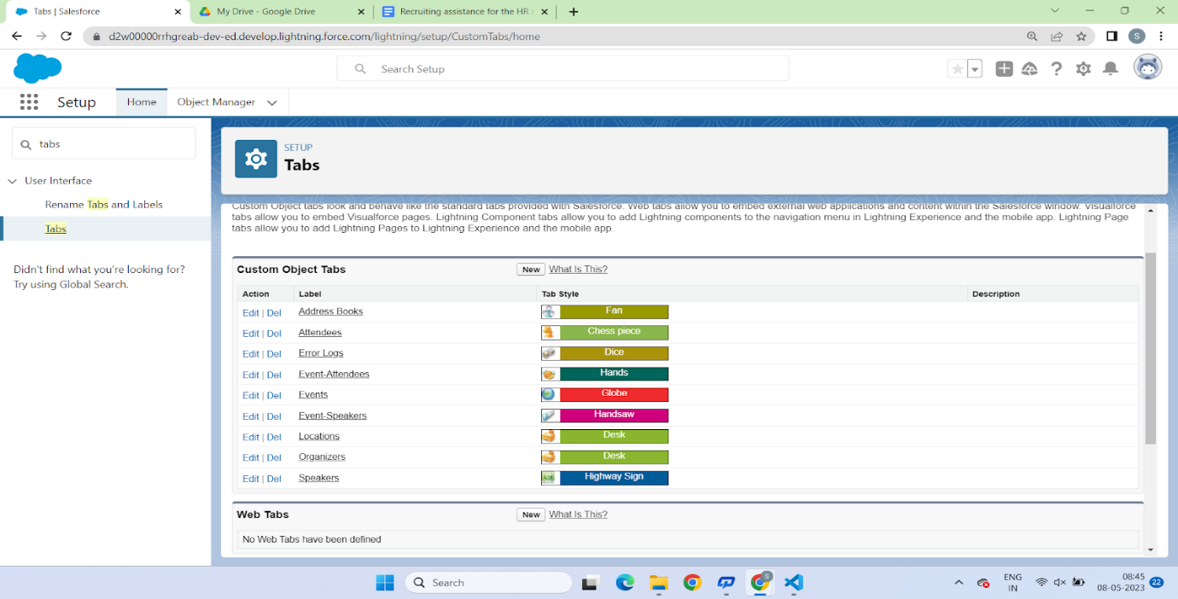  
  
4. Than select the Customer Detail Object and select the Icon from the search button and click next next and save  
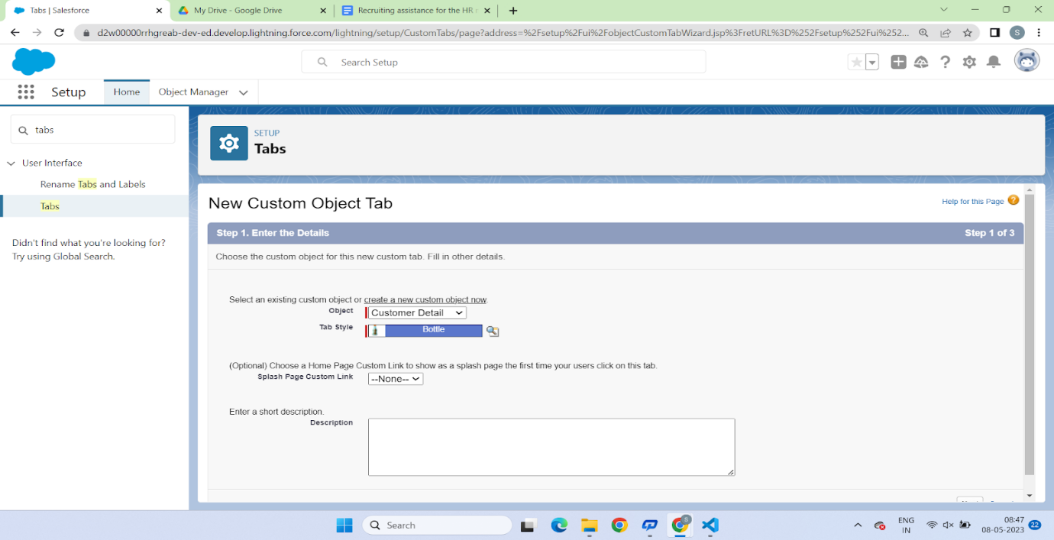  
  
For creating  the Remaining tabs follow the above steps

1. For creating a tab for EveryDay Value Tab follow the above steps which is being create in step1 for customer details
2. For creating a tab for Best Seller Tab follow the above steps which is being create in step1 for customer details
3. For creating a tab for New Launches Tab follow the above steps which is being create in step1 for customer details
4. For creating a tab for Veg Pizzas/Non veg Pizzas Tab follow the above steps which is being create in step1 for customer details
5. For creating a tab for Beverages Tab follow the above steps which is being create in step1 for customer details
6. For creating a tab for Mode Of Payment Tab follow the above steps which is being create in step1 for customer details

### Create The Lightning App

1.Go to the Gear Icon ? Click on setup ? click on the Home Button ? Go to the quick find box and select the App Manager  
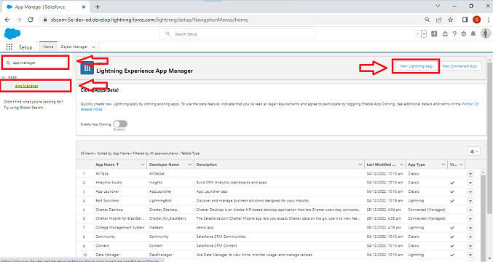  
2.Fill the app name as an Pizza Delivery in app details and branding ?Next ? (App option page) keep it as default ? Next 3. Utility Items keep it as default ? Next ? (Add Navigation Items)(add tabs Customer Details, Every Day Values, Beverages, Best Seller, New Launches, pizza and Mode of payment) ? Next ? (Add User Profile) Add System Administrator, Salesforce platform user, Standard User ? Next.  
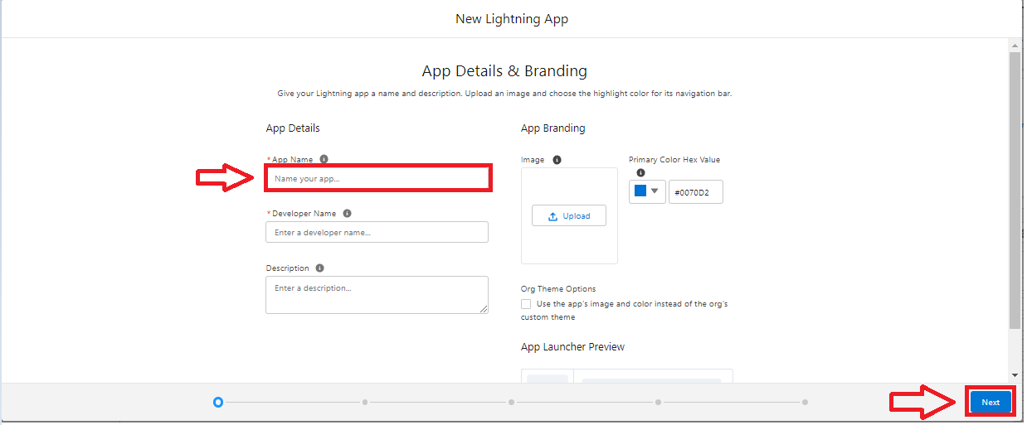  
4. To Add Navigation Items: Select the items from the search bar and move it using the arrow button ? Next. select all the tabs which you have created   
5. To Add User Profiles: Search profiles in search bar ? click on the arrow button & select Standard user, standard Platform user & System Admin Profile? save & finish.  
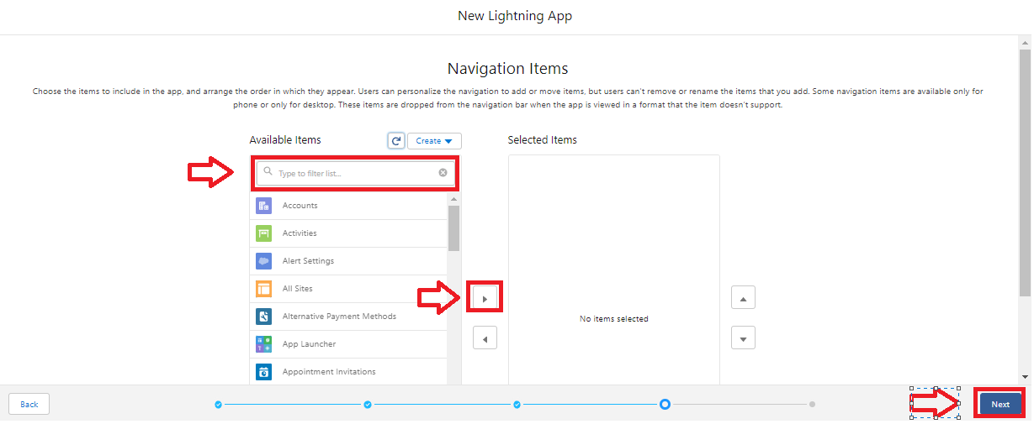

### Fields & Relationships

### Create The Field(EveryDay Value? Delivery Field)

1. Go to setup ? click on Object Manager ? type object name in search bar ? click on the object? EveryDay Value ? Field and Relationship? then click on new ?Field Data Type(Checkbox)  
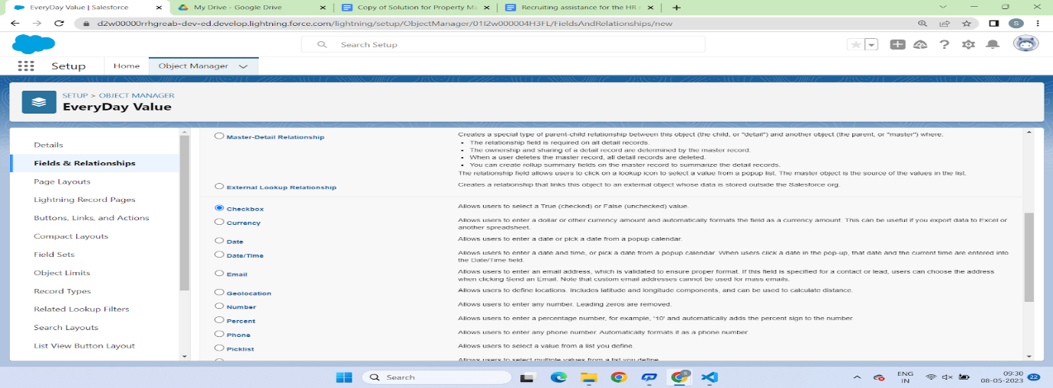  
  
  
2. Click On Next? Field Label?Delivery? next?next?Save.  
  
  
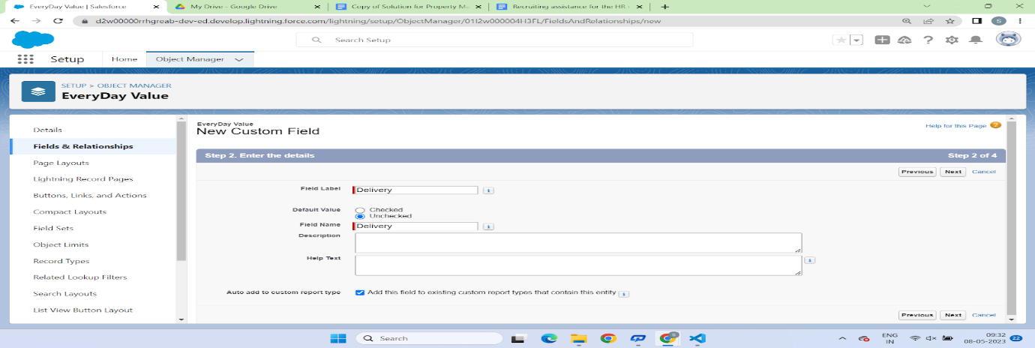  
  
  
3. Follow the above steps and create the Remaining Fields.

* Pickup(Checkbox)
* Select City(Picklist)(New Delhi, Mumbai, Bangalore, Pune, Chennai, Hyderabad, Kolkata, Noida, Agra, AhmadNagar, Ahmedabad, Nasik )
* Select Store(Picklist)(Deolali Camp, Bytco Point, Satpur Nashik, Hitech City, Gachibowli,  Indira nagar, Kelambakkam, Noida City )
* Delivery(Checkbox)
* Pickup(Checkbox)

### Create The Field(Best Seller Obj)

1. (Best Seller obj? Size field)  
2. Crust(Picklist)(New Hand Tossed ?459, 100% Wheat thin crust? 524, Cheese Burst? 578, Fresh pan Pizza?514)

### Create The Field(New Launches)

1. New Beverages(Picklist)    
2. Options

### Create The Field For (Pizza)

1. Types of  Pizzas(PickList)(Paneer Makhani, Margaretha, Onion Pizza, Tomato pizza, Paneer Chicken, Chicken pizza)
2. Amount(PickList? 100, 200, 350, 400, 500, 550,750, 850)
3. Add On ? (Number Field Data type)

### Create The Field(Beverages)

1. Types of Cold Drinks(Picklist)(Mountain Dew Ice, Nagpur Orange, Pepsi 475ml, 7Up 475ml,Mirinda)

### Create The Field(Mode Of Payment)

1. Mode Of Payment(Picklist)(Debit Card, Credit Card, UPI Payment)

2. Master detail Relationship with(Customer Details)

### Record Types

### Record Type For Pizza Object

1.Click On the Gear Icon? Then Click on the the object Manager? Search for Pizza object? Record Types ? Click on new? Veg Pizza  
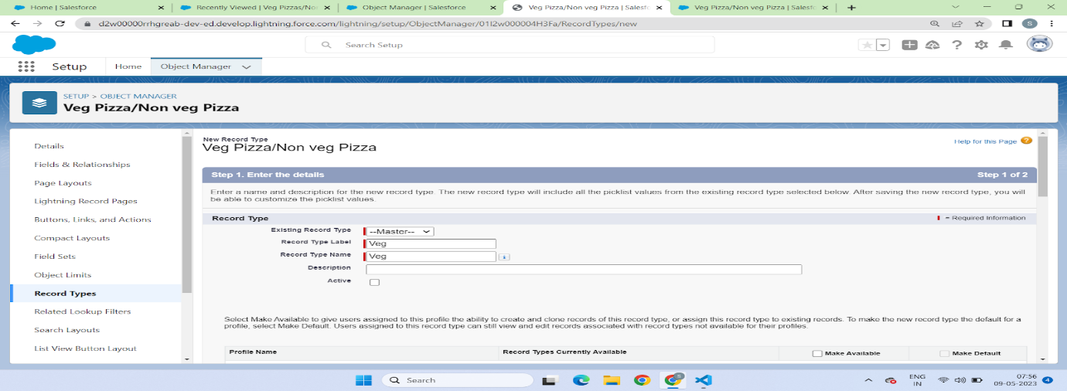  
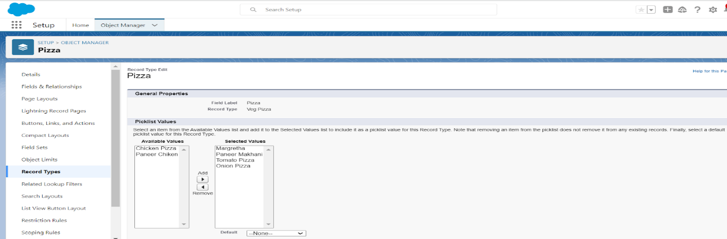  
  
  
  
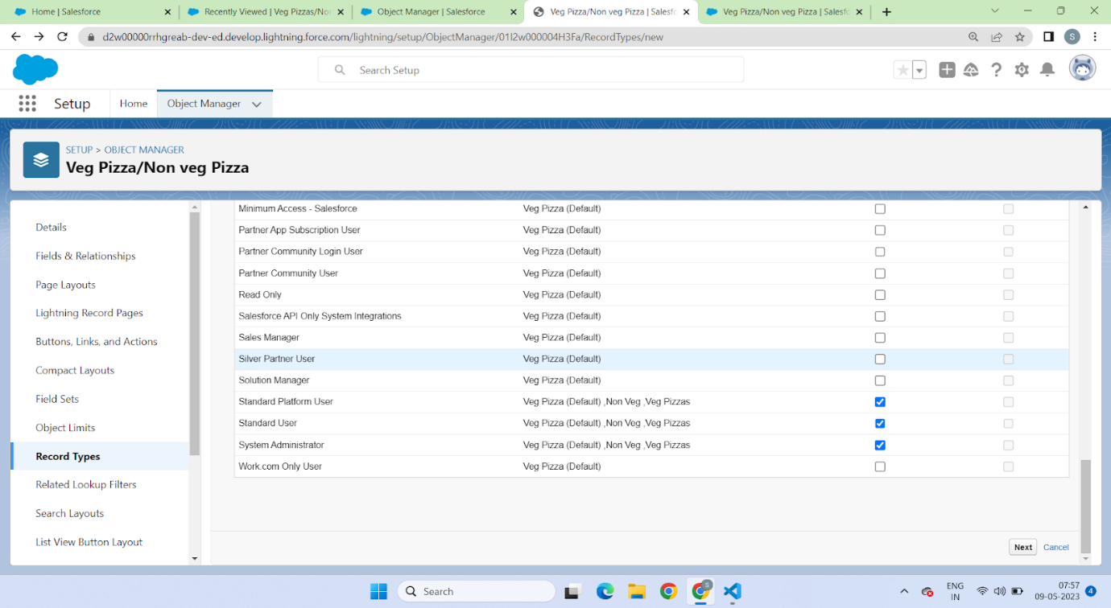  
  
  
  
  
  
2. Similarly do for the Non-veg and just select the non-veg instead of veg

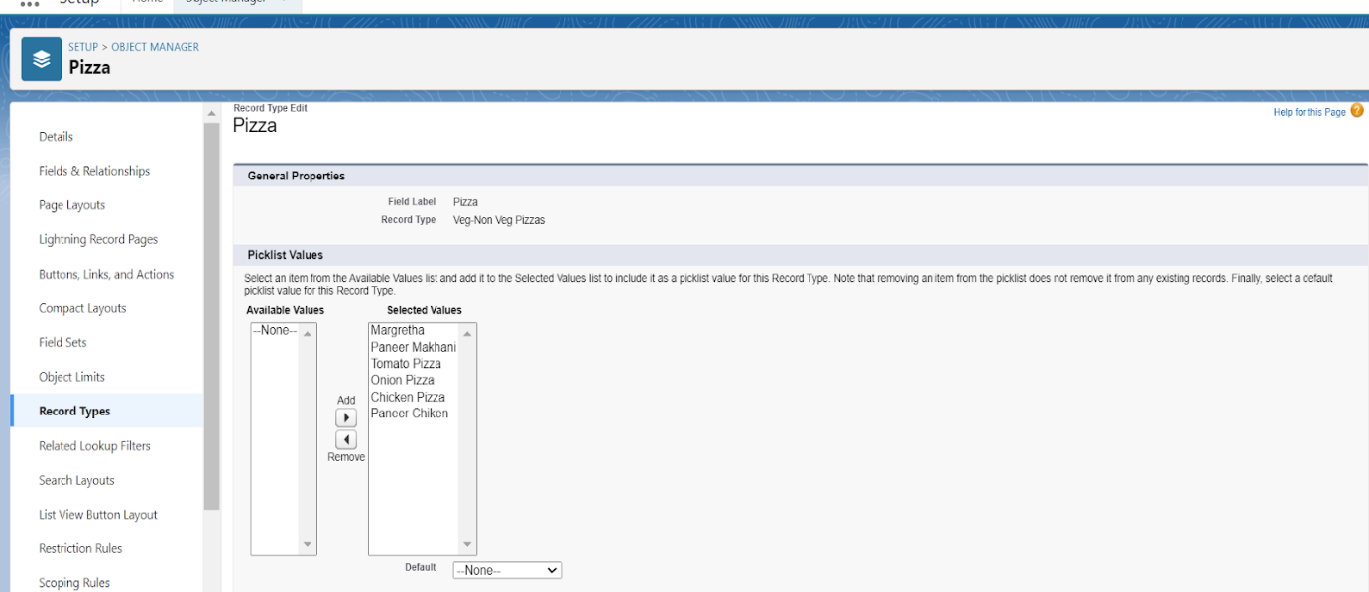

### Profile

### To Create A New Profile

1. Go to setup ? type profiles in quick find box ? click on profiles ? clone the desired profile (standard platform user is pref) and clone that profile  
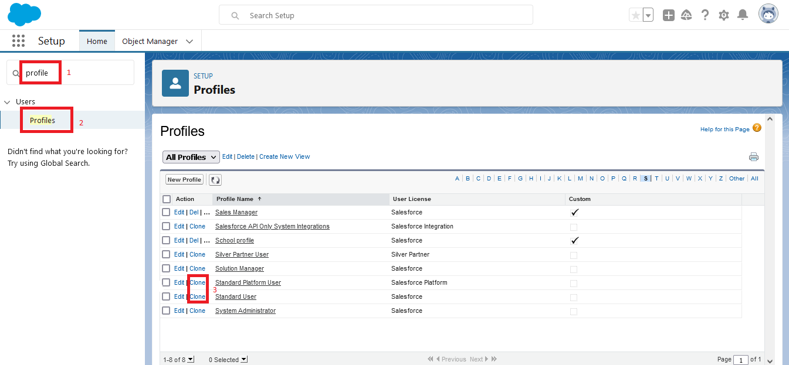  
  
2. Enter a Profile Name(Sales Manager) And click on Save  
3. Click on the new created profile  
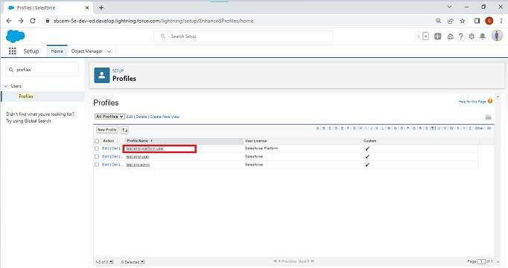  
  
  
4. While still on the profile page, then click Edit.  
  
  
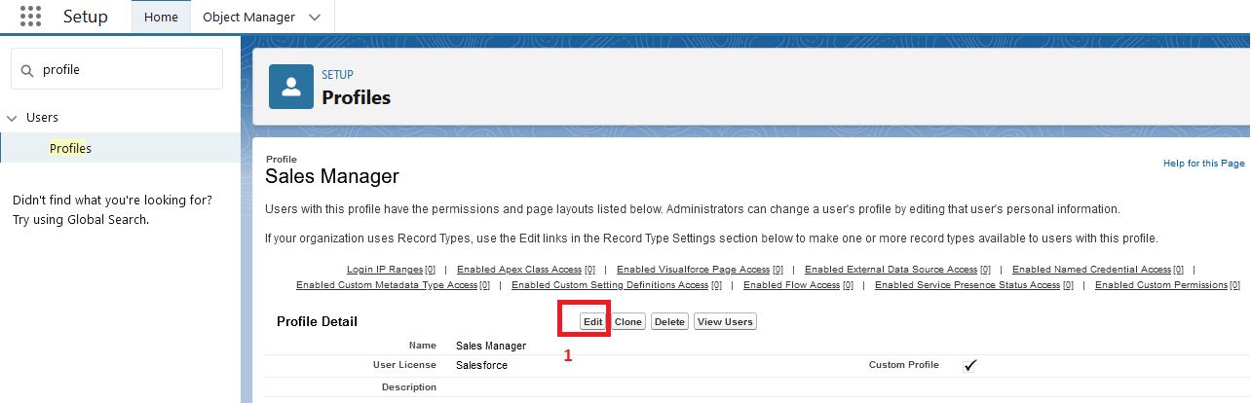  
  
5.For the sales manager profile give the following access  
  
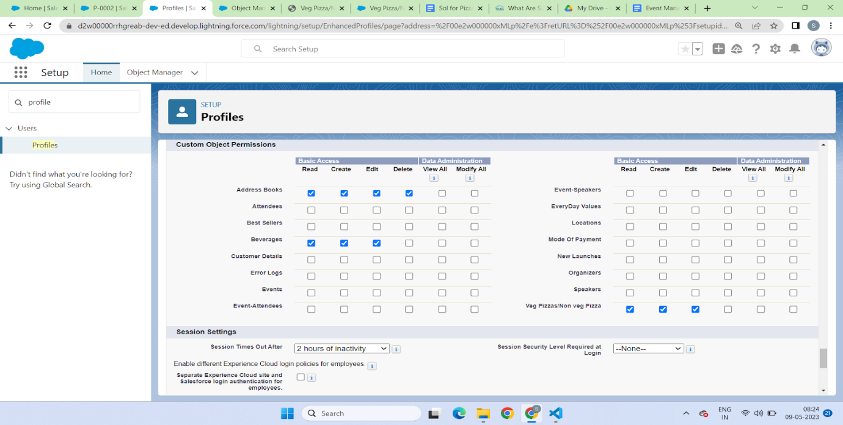  
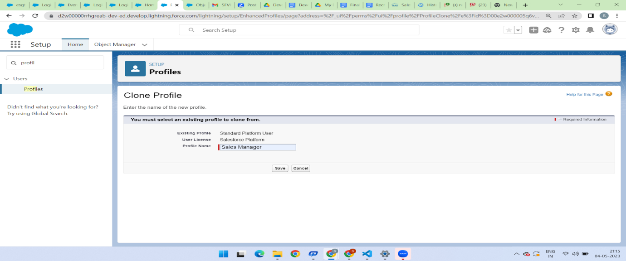  
  
  
  
6. Similarly clone the standard platform profile and give the name as Sales Executive  
And give the same access to the as of sales manager  
  
7. Again clone the standard User profile and this time give all access for the objects, tabs and field  
And give the profile name as Delivery Person

### User Adoption

### Activity - 1

1.Go to the Gear Icon? Click the setup?click on the home button and in the quick find box search for the user ?Click on the user? than click on new  ?fill the fields  
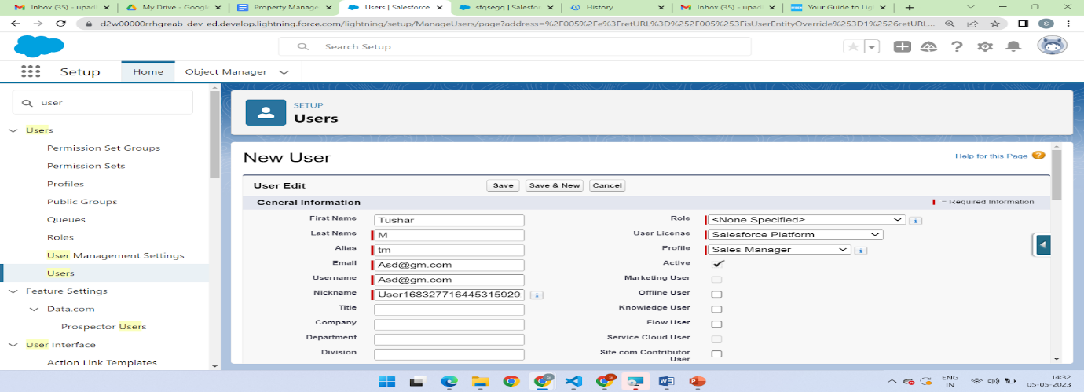  
  
2. Follow the above and create 2 more user? Marketing manager and Sales Rep

### OWD(Organization Wide Default)

### Create OWD Setting

1. Setup, use the Quick Find box to find Sharing Settings.

2. Click Edit in the Organization-Wide Defaults area.

3. For each object, select the default access you want to give everyone.

4. For Every custom object give private as a record level security

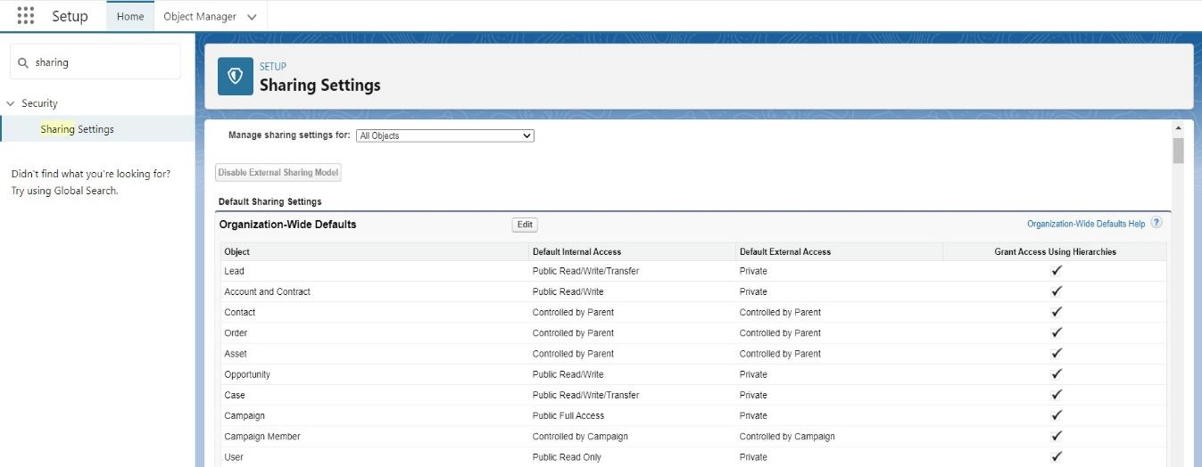

### Reports

### Create The Report

1. Go to the gear icon ? click on the setup?click on the home button? in the the quick fin box search for app manager select the App and go to the navigation? There select the Report and include in the app ? than go to App There you will find the Tab  
  
2. Click New Report? create folder?Create the Report? Select the Customer with Mode Of Payment Object Mode of Payment in the columns? Customer detail:Created Date ? columns? mode of payment:Id and in the rows?Mode of payment?Mode of payment  
  
  
Select Start Report:  
3. For to the reports and select the ? customer details with mode of payment  
  
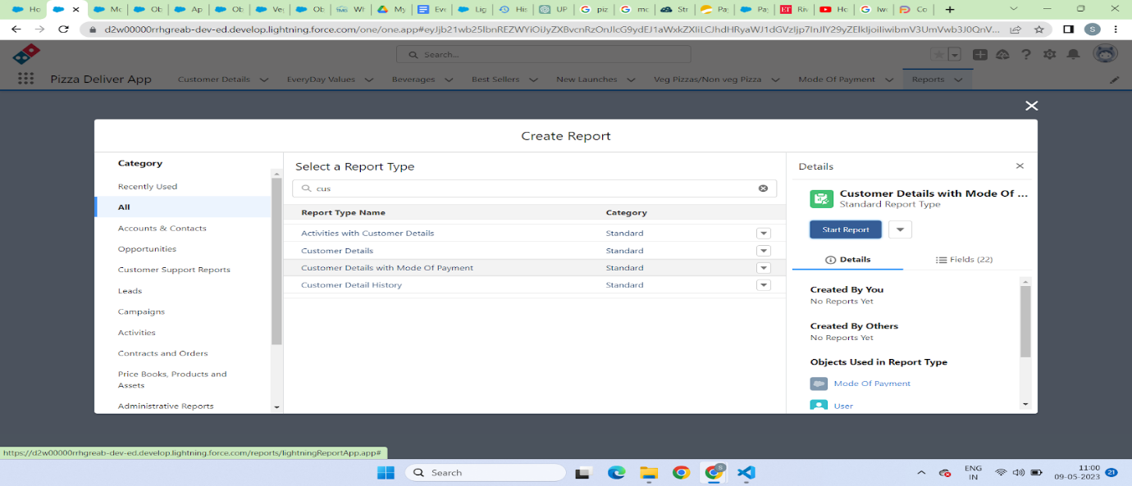  
  
  
  
  
  
  
4. Select the following option for the Rows and column  
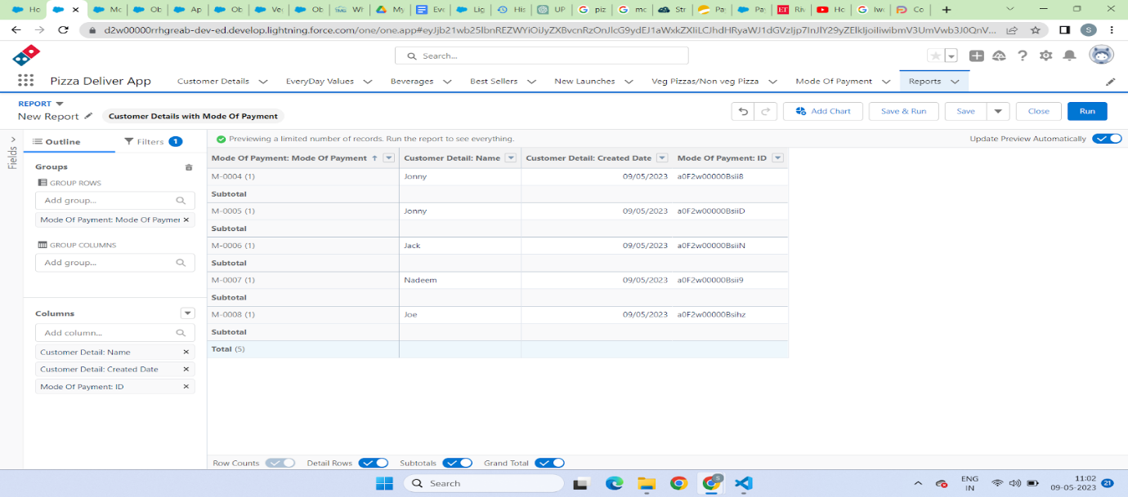  
  
  
5. You can  create the chart as so just click on the chart and you will be able to create it

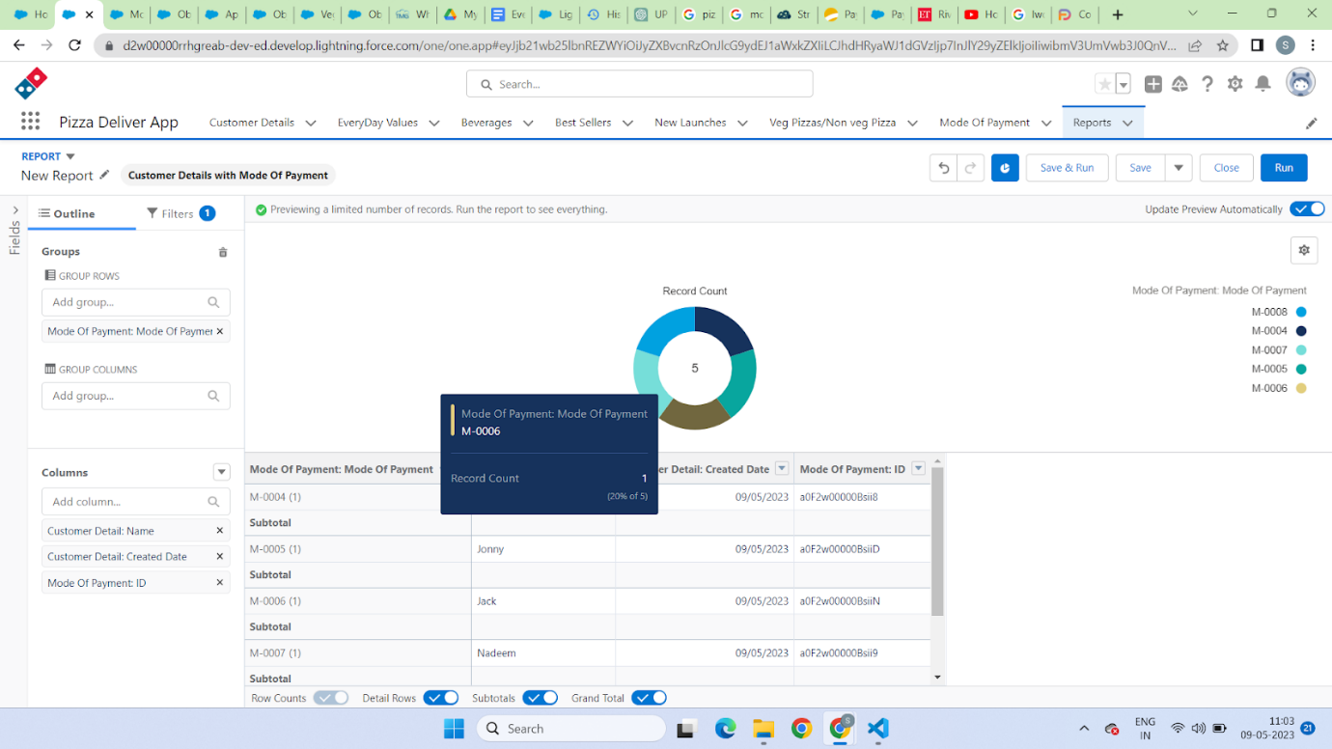

### Apex Trigger

Use Case: This Trigger works for the Pizza Object where the scenario is like whenever the customer is selecting the Pizza whether it is veg Pizza or Non-veg Pizza According to the selection of Pizza The Amount will be reflected in the “Amount” Field.

Trigger:

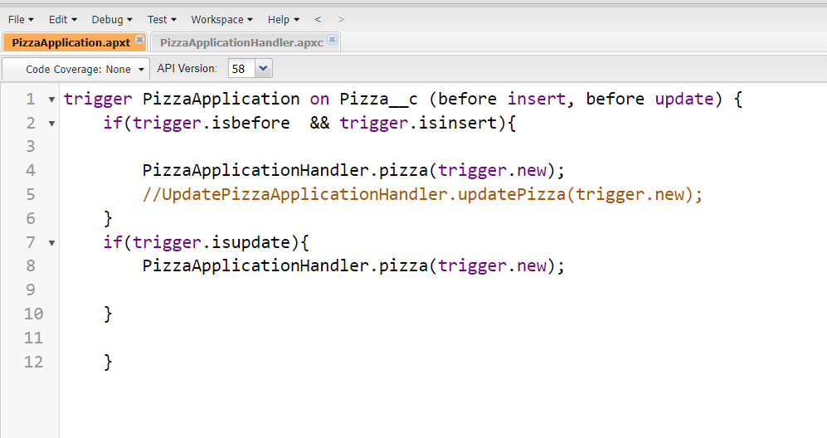

Trigger Handler:

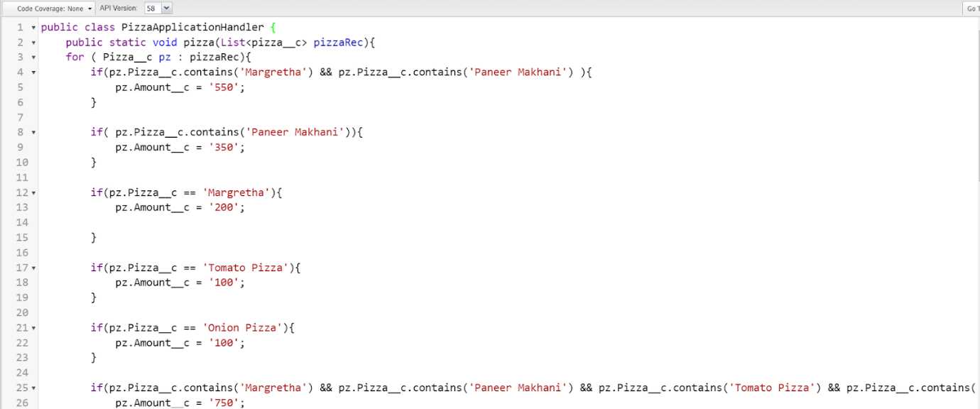

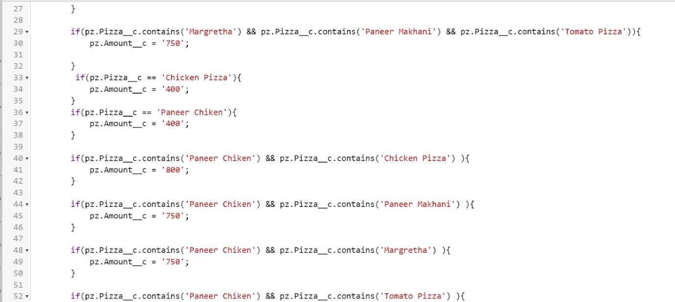

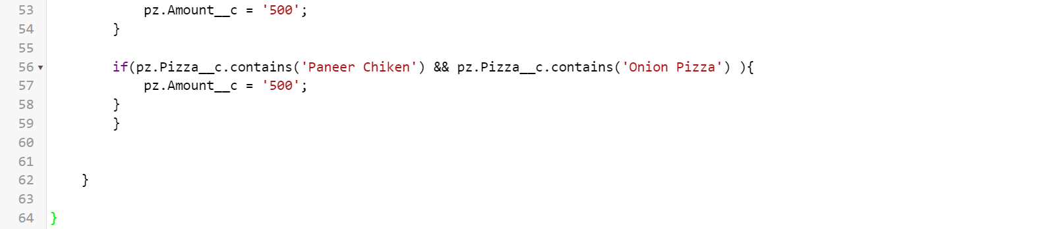

### Schedule Apex

### Schedule Apex For Frequently Visited Customer

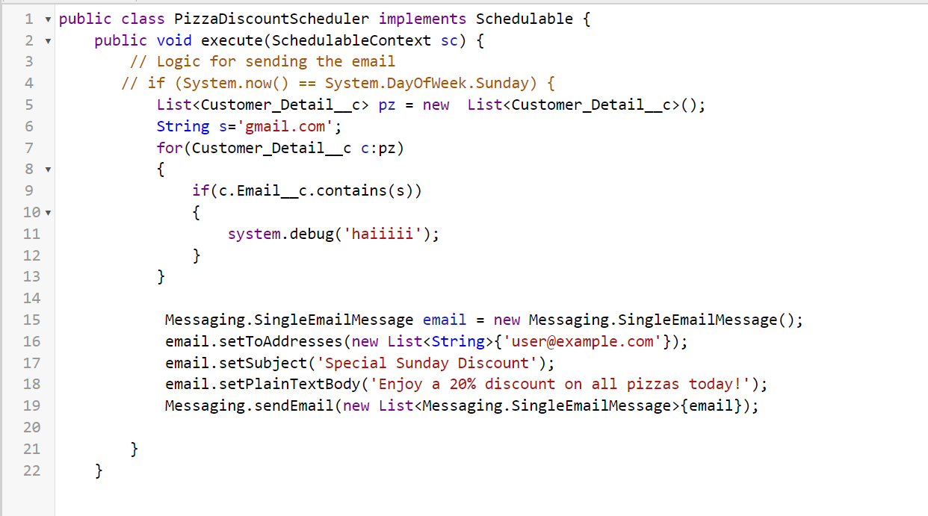

public class PizzaDiscountScheduler implements Schedulable {

    public void execute(SchedulableContext sc) {

        // Logic for sending the email

       // if (System.now() == System.DayOfWeek.Sunday) {

           List<Customer_Detail__c> pz = new  List<Customer_Detail__c>();

           String s='gmail.com';

           for(Customer_Detail__c c:pz)

      {

               {

                   system.debug('haiiiii');

               }

           }

            Messaging.SingleEmailMessage email = new Messaging.SingleEmailMessage();

            email.setToAddresses(new List<String>{'user@example.com'});

            email.setSubject('Special Sunday Discount');

            email.setPlainTextBody('Enjoy a 20% discount on all pizzas today!');

            Messaging.sendEmail(new List<Messaging.SingleEmailMessage>{email});

             }

    }

### Activity-2

For Making the Schedule to send Mail To the Customer Follow the steps below:  
Click on the Gear Icon? Go to the Home Tab ? In the Quick Find Box ? Search for Apex Class   
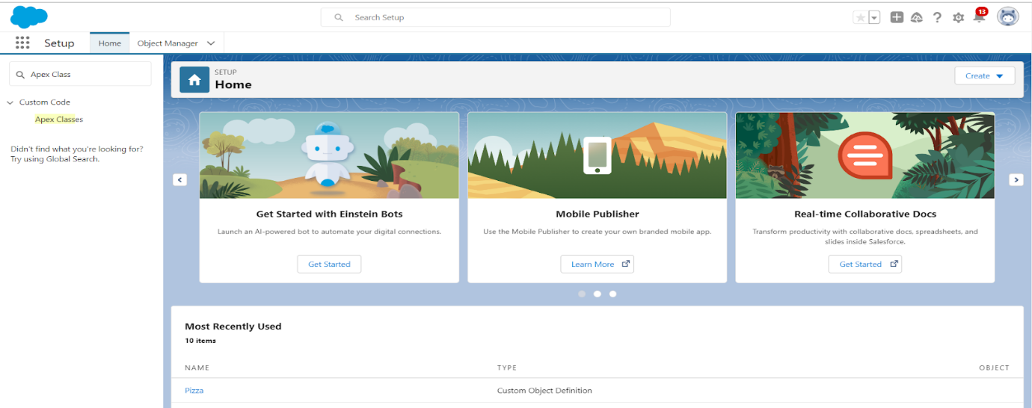  
  
  
  
  
  
  
  
  
2. Click on the Schedule Apex ? Give Job Name As ? Schedule Pizza.  
  
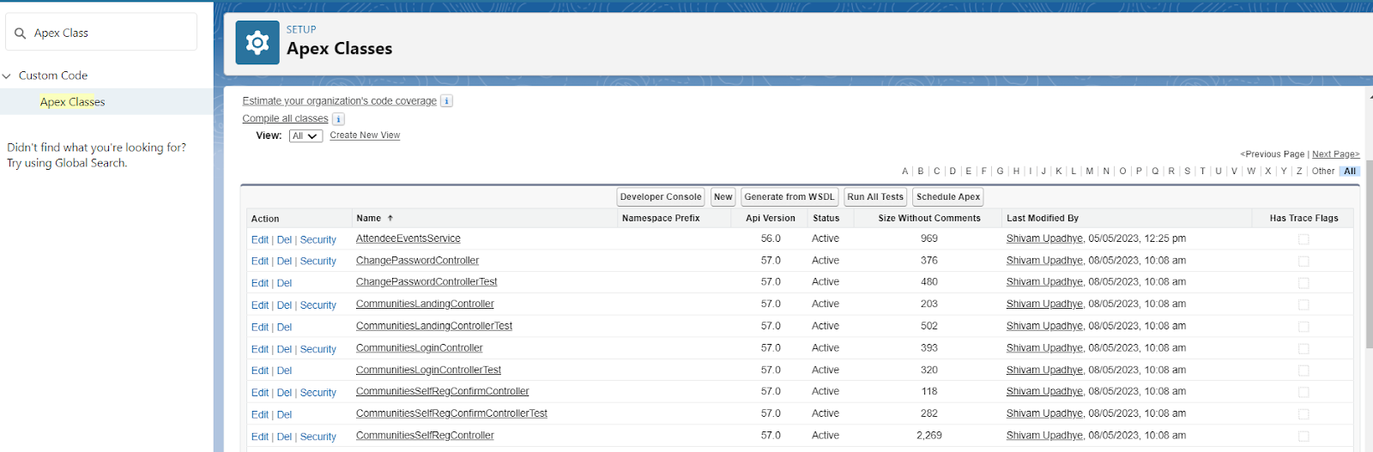  
  
  
  
  
  
  
  
3.Click on Apex Class Lookup  ? Select PizzaDiscountScheduler In Recently Viewed Apex Class  
  
  
  
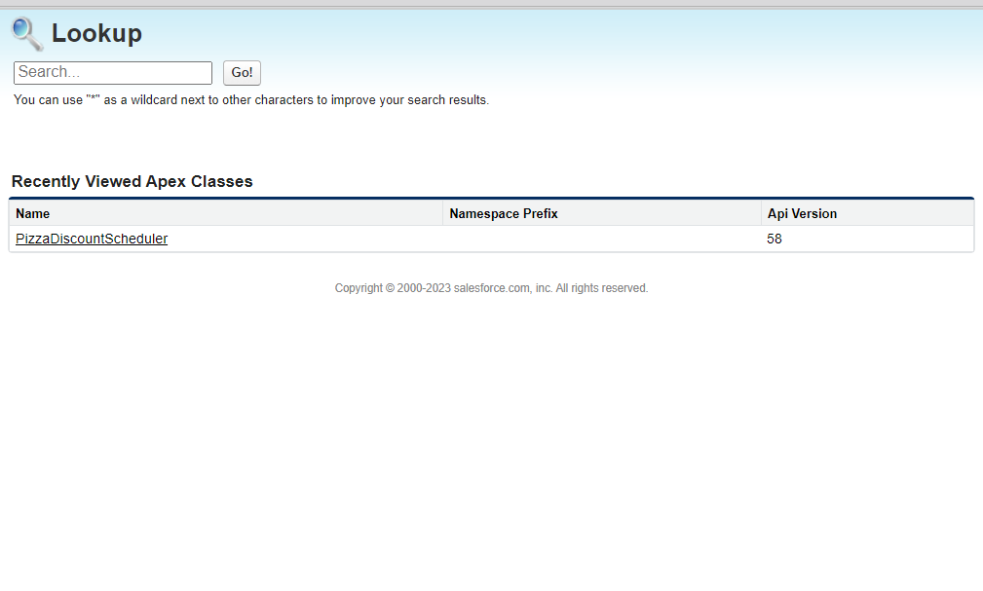  
  
  
  
  
  
4. In Frequency Click on the Weekly Radio button You can Select the Start Date and Enddate As Per You Requirement and then Click on the Save Button.   
